GE Healthcare

Information Technology and Process Excellence

System Design Specification for Smart Dispatch Tool (SDT) Booking

Document Authorization:

|  |  |  |  |  |
| --- | --- | --- | --- | --- |
|  | Name | SSO | Project Role | Department |
| Author(s) | Rajesh Babu Kallem | 502533753 | Technical Lead | GE – TechM |
| Reviewer(s): | Joy Chakraborty | 502449179 | Business Enterprise Architect | GE – TechM |
| Chandramohan Gupta | 320000277 | Systems Owner | GE - ITPE |
| Design Reviewer | Raja Raman | 212069259 | Systems Architect | GE - ITPE |
| Code Reviewer | Rajeshbabu Kallem | 502533753 | Development Lead | GE – TechM |
| Approver(s): | Murali Manda | 502587708 | Project Manager | GE – TechM |
| Mahesh Iyer | 212069417 | Validation Manager | GE - IT&PE |

Document Revision History

A record of changes made to this document by the project team.

| Revision | Date | Author | Change Reference | Reason for Change |
| --- | --- | --- | --- | --- |
| 1 | 06th June 2016 | Joy Chakraborty | Initial document | Initial Release |
| 2 | 24th June, 2016 | Joy Chakraborty | Updated SDS-13-03 | Task Duration for Installation Job Type to be listed in ‘Hours’ instead of ‘Days’ |
| 3 | See MyWorkShop | Sid Subudhi | Added a new SDS-03-09 for the new requirement SRS-03-09 | CHG0076367 - Added a new SDS-03-09 to implement one very specific business scenario for Korea where same day Extended slots are not retrieving for FSEs to make a visit to the customer site. |
| 4 | 3rd May, 2017 | Jayesh Soni | Added a new SDS-15-01 to SDS-23-01 for the new requirement | Added new from SDS-15-01 to SDS-23-01 for the new requirements to customize SDT. |

Contents

1 Introduction 6

1.1 Document Purpose 6

1.2 Scope 6

1.2.1 Inclusions 6

1.2.2 Exclusions 6

1.3 Dependencies/Prerequisites 6

1.4 Assumptions 7

2 Concept Definition 7

2.1 Selected Concepts 7

2.2 Design Goals 8

2.3 Design CTQ’s (Critical to Quality) 8

2.4 Design Trade-offs 8

3 Overview of system 9

3.1 SDT Booking 10

4 Application Design/Software Components 11

4.1 System Components 11

4.1.1 Hardware: 11

4.1.2 Software: 11

4.2 Activity Diagrams 12

4.3 Sequence Diagrams 13

4.4 Design Specifications 16

4.4.1 System Requirements 16

4.4.2 Performance Requirements 30

4.4.3 Network Requirements 30

4.5 User Interface 30

4.6 Integration and Interface Protocols 33

4.7 Reports 33

4.8 Application/System Availability and Disaster Recovery 33

5 Database 33

6 Design Review 33

7 Design for Testability 33

7.1 Test Data 33

7.2 Code Review 34

7.3 Unit Test 34

8 Security 34

8.1 Authentication 34

8.1.1 Internal User Access 34

8.1.2 External User Access 34

8.2 Authorization 34

8.2.1 Application Level 34

8.2.2 Desktop Level 35

8.2.3 Field Level 35

8.2.4 Reporting 35

8.3 Data 35

8.3.1 Classification 35

8.4 Patching & Upgrades 35

8.4.1 Patching 35

8.4.2 Upgrades 35

8.5 Security Specifications 35

9 Legal, Compliance, Regulation 36

9.1 21 CFR Part 11 – ERES 36

9.2 Sarbanes-Oxley 36

9.3 HIPAA, Data Privacy 36

10 Error Handling & Recovery 37

11 System Architecture 37

11.1 Proposed System Architecture 37

12 Deployment Plan 39

12.1 Hosting Architecture 39

12.2 Deployment Process 40

12.3 Interface Deployment Process 40

12.4 Maintenance & Support 40

12.5 Retirement Strategy 40

13 Risks/Issues 40

14 Traceability Matrix 40

15 References 41

15.1 Document References 41

15.2 Definitions 41

16 Appendix 42

16.1 Appendix A- List of Countries 42

# Introduction

## Document Purpose

The purpose of this System Design Specification (SDS) document is to describe the agreed system design for SDT Booking. This document shall satisfy the stated needs of APAC Services as outlined in the User/System Requirement Specification (USRS) document [3].

## Scope

### Inclusions

This document describes System Design Specification for:

* SDT Booking web
* Communication Protocol between SDT Booking and Siebel
* Communication Protocol between SDT Booking and Click

### Exclusions

The following Items are excluded from this SDS:

* Internal logic of SDT Schedule Application.
* Internal logic of SDT Mobile Application.
* Internal logic of Siebel Application.
* Internal logic of Siebel API
* Internal logic of Middleware
* Communication protocol between
  + SDT Schedule and Siebel
  + Middleware and Siebel
  + Middleware and Click

## Dependencies/Prerequisites

Table 1‑1: Dependencies/Prerequisites

| **Dependency/Prerequisite** | **SDT Booking** |
| --- | --- |
| Availability of Siebel | Yes |
| Existence of a Siebel predefined userid for launching the Siebel API through a button CLICK | No |
| Availability of Siebel API | Yes |
| Availability of SDT Schedule on Internet network and correct access to Web services | Yes |
| SMTP Server connection with valid user access | No |
| The following distribution lists are used by SDT Booking for administration and support  @HEALTH APAC-SDT | NA |

## Assumptions

Environment Requirements for SDT Booking are specified in the Technical Architecture Description (DOC1757330) for SDT Booking [4].

# Concept Definition

## Selected Concepts

The global aim of SDT Booking is to enable SDT Schedule to/from interfaces with the Siebel system.

Considering SDT Schedule is a cloud resource scheduling optimization solution (ClickSchedule) and Siebel is the CRM system used in APAC countries except Japan, managing Request for Service (RFS) life cycle from initiation to closure, the selected concept to exchange information is based on the following applications:

* SDT Booking that is a web based application used by service center agent to initiate the scheduling of a RFS

As SDT Schedule is based on web architecture and is using WCF services in data exchange, SDT Booking and Siebel are developed under Web architecture for compatibility reasons with SDT Schedule.

Design architecture used for develop SDT Booking is called MVC (Model, View, Controller) (<https://en.wikipedia.org/wiki/Model%E2%80%93view%E2%80%93controller>).

## Design Goals

The goals for SDT Booking design are the following:

* Ease of integration with Siebel through REST APIs
* OAuth Authentication Layer
* Scalability
* Ease of integration with Click Software.
* Testability
* Ease of integration with future CRM system

## Design CTQ’s (Critical to Quality)

* SDT Booking tool shall be easy to use by the CSC agent.
* Use of SDT Booking shall be compatible with normal use of Siebel screens.
* Ensure the appropriate RFS are sent to SDT Schedule from SDT Booking.
* Adaptability to support future changes.
* Ability to manage user interface in different languages.

All SDS IDs listed below are critical

## Design Trade-offs

No specific design trade-offs has been considered for SDT Booking.

# Overview of system

Below is the SDT Booking overall design, illustrating its sub-systems and interfaces to existing Information Systems

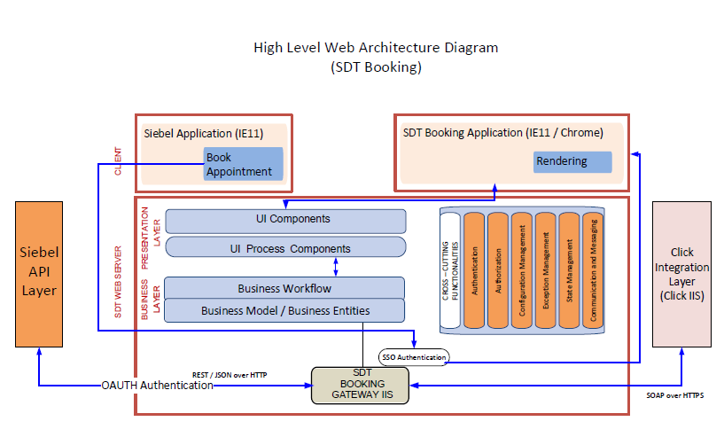

Figure 3‑1: SDT Web Overview Diagram

## SDT Booking

SDT Booking shall:

* Extract Siebel RFS data.
* Display summary of the Siebel data to SDT Booking.
* CSC-Agent can update the information needed to get the request assigned.
* On request SDT Booking provides the CSC-Agent with a list of available slots from SDT Schedule (ClickSchedule).
* To get the RFS assigned in SDT Schedule with an appointment:
  + CSC-Agent shall select a slot after confirming suitability with the Customer.
  + CSC-Agent should create / update a visit in SDT schedule with customer’s agreed appointment slot.
* To get the request assigned in SDT Schedule without an appointment, CSC-Agent shall request the assignment without appointment.
* SDT Booking shall create a temporary assignment in CLICK.

# Application Design/Software Components

## System Components

### Hardware:

SDT Booking Application is a web based tool thus no specific hardware requirement is there.

### Software:

No software requisite for SDT Booking other than default provided by Windows Server.

## Activity Diagrams

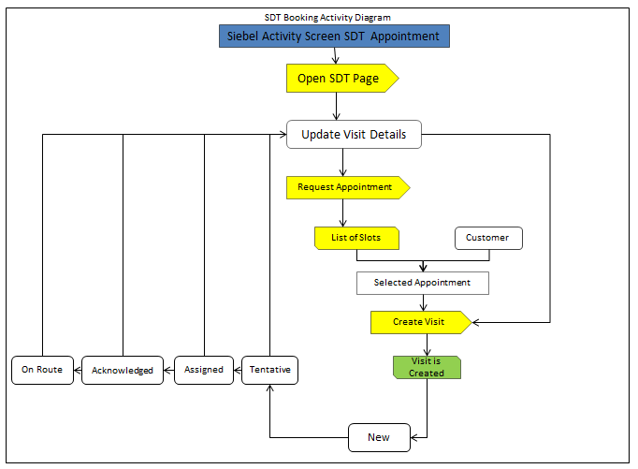

Figure 4‑1: SDT Booking Activity Diagram

## Sequence Diagrams

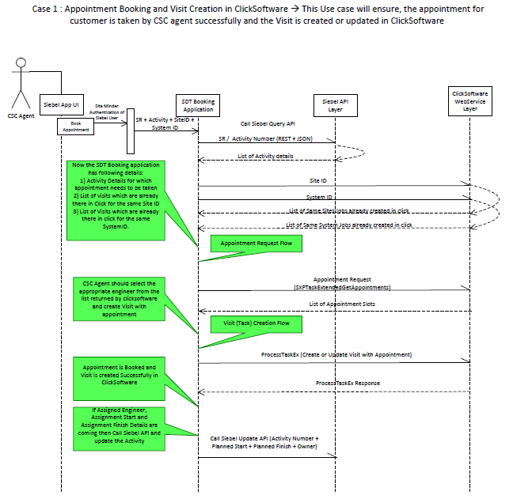

Figure 4‑4: SDT Booking Sequence Diagram (Case 1)

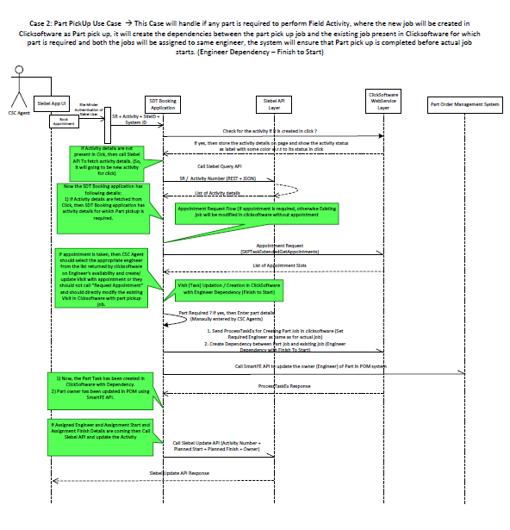

Figure 4‑5: SDT Booking Sequence Diagram (Case 2)

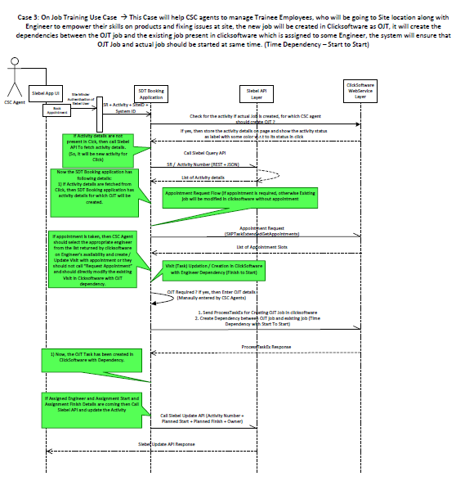

Figure 4‑6: SDT Booking Sequence Diagram (Case 3)

## Design Specifications

### System Requirements

Table 4‑3: SDT Booking Functions/Job Streams/Objects

|  |  |  |  |
| --- | --- | --- | --- |
| **SRS ID** | **Design ID** | **Title** | **Description** |
| SRS-01-01 | SDS-01-01 | Create Visit with appointment | Start Request Appointment Booking process by: |
| -    Navigating into SDT Booking Application Home Page |
| -    Getting SR and Activity Number from SIEBEL |
| -    Getting the information for already created visits from SDT Schedule if any. No information is displayed when no prior visit request has been made. |
| -    Getting Early Start ,Late Start and Duration from SIEBEL on the basis of SR Type or If job is already created in ClickSoftware, then ES / LS will be retrieved from ClickSoftware Task. |
| -    Key in all the required fields and Request appointment button will be enabled based on the Task status as per the business logic. |
| Request Appointment Slot To Click | Request appointment to SDT Schedule and receive slots to be checked and validated by CSC with the customer. This feature is available when no corresponding tasks is defined in SDT Schedule or when the SDT Schedule task status is “New” or “Tentative” |
| Create Visit | Create or update task in Click. The feature is responsible for creating task with selected appointment slot for the FSE. |
| SRS-02-01 | SDS-02-01 | Create Visit without Appointment | 1. Service center users shall be able to get recommended assignment(s) through SDT Booking ONLY for jobs NOT yet created in CLICK after providing the applicable criteria without having an appointment with the customer. |
| 2. The user launches SDT Booking from the Siebel International service request/activity screen. |
| 3. User can directly create the job with the values retrieved from the Siebel System to create a task in CLICK. The details of the task would be similar to what has been created in Appointment booking with the difference of Appointment slots not being captured in the request. |
| 4. Depending on service request/Activity type, user updates the criteria (if required) for optimizing visit schedule (ES, LS, Duration, FE Skill, Required FE, Timeslot Preference (AM/PM, 1 OR 2 hour slots). |
| 5. ES, LS Validations fires based upon Inputs given on the screen. |
| 6. “Create Visit without appointment” option enables only for new visit. |
| User selects “Create Visit without appointment” option. (For existing visit, field labelling should change as "Modify visit). |
| 7. Once User click the “Create Visit without appointment” option, based upon inputs the new visit will create in click server and the details will be returned back to home screen with assigned status and “Create Visit without appointment” option will be changed to “Modify Visit”. |
|  |
| SRS-03-01 | SDS-03-01 | ExtendedGetAppointmentsEx2 | 1.  Request appointment enables to receive slots from SDT Schedule which CSC agents can check and validate as per customer requirement. |
| 2. SR/Activity details are fetched from Siebel in Main screen of SDT Booking. These values can be modified by CSC agents based on customer request. (Early Start, Late Start, Task Duration, FSE Skill level, appointment window). |
| 3.  All inputs from Siebel or from user input to be validated and appropriate error message / pop-up windows to be shown. |
| 4.  Request appointment feature is available when no corresponding tasks is defined in SDT Schedule or when the SDT Schedule task status is “New” or “Tentative” |
|  |
| 5. After sorting of slots should be enabled for all the fields in the grid. conditions are verified, user can click on request appointment button |
| 6. Each slot has a scoring to determine the best appointment slot to CSC agents. Higher the Click score, better the slot. Higher scored slots will be displayed on top of the page.(for all  job types other than PM) |
| 7.Check if slot requires bumping other tasks and, in this case, bumped task details are displayed |
| - Refer Notes. |
| SRS-03-02 | SDS-03-02 | Request Appointment slots | 1.Early Start & Late Start dates, appointment window selected and record count shall be displayed at the footer of the Request appointment grid for all job |
| 2. Upon click, list of slots are retrieved from SDT schedule based on the parameters Early start and Late Start. The slots should be retrieved within 10 seconds. |
| types. The header will display: Proposed Slots for appointment. |
|  |
| SRS-03-03 | SDS-03-03 | Request Appointment | There are two types of slots - First normal slots are retrieved. Upon click of "More extended slots", extended slots are retrieved to show all the available possible slots to CSC agents |
|
| SRS-03-04 | SDS-03-04 | Request Appointment | Request Appointment slots will be displayed for the Field Engineers when clicking on Request Appointment Slot button from Mail screen of SDT Booking. The receive slots to be checked and validated by CSC with the customer |
|
| SRS-03-05 | SDS-03-05 | Request Appointment | For PM jobs, if desired date exists, the slots near the desired date should appear on top of the page.  If Desired date is blank from Siebel, the slots will be displayed in the ascending order of the appointment date. |
|
| SRS-03-06 | SDS-03-06 | Request Appointment | SLA Logic has been modified as per requirements from Business at last moment. (After SIT in Korea).  The initial SLA logic looks for ES / LS from Click on the basis of OpenDate from Siebel and Click will check if Contract is defined for specific SystemID then ES and LS offset will be applied by click in order to set ES / LS values for In SLA slots. Apart from that whatever ES / LS defined by user on UI will After SLA slots. |
|
| SRS-03-07 | SDS-03-07 | Request Appointment | Once the slots are retrieved, upon selection of a slot visit shall be created in CLICK for a new job using "Create Visit" button. If the visit already exists in CLICK, "Create Visit" button will not exist and instead the user sees a "Modify Visit" button. |
|
| SRS-03-08 | SDS-03-08 | Request Appointment | Few Duplicate slots were initially returned from external system but now in SDT Booking we have handled the scenario of not having any duplicate slots. Duplicate can happen in very rarest case where click can calculate 2 different scores for same Appointment slot. |
| SRS-03-09 | SDS-03-09 | Request Extended Slots | Extended slots were missing when ES and LS were given as same dates even though the slots were offered from click. This was due to the business rule that states the slots returned should be shown within the ES and LS range given in the UI of the home page. |
|
| SRS-04-01 | SDS-04-01 | Cancel Visit | 1. The user launches the SDT Booking from the Siebel International service request/activity screens. |
| 2. Validate the data as per the business rules for enabling the Cancel Visit button |
| 3. If the value of task status is New/Rejected/Tentative/Acknowledged/Rejected by FSE/Assigned then Cancel Task in SDT button should be enabled in the screen Else button should be disabled in the screen |
| 3 A task can be cancelled in SDT Schedule only if it has the following status: “New”, “Rejected”, “and Rejected by FSE”, “Tentative”, “Assigned" or "Acknowledged". |
| 4. Select the "Cancel Visit" option. A confirmation message should pop-up giving the user an option to continue or cancel the selection |
|  |
| SRS-04-02 | SDS-04-02 | Cancel Visit | 1.The SDT Booking shall not allow cancellation of tasks in Click schedule for the following statuses: Enroute, Onsite, suspended, completed, Incomplete |
| 2. For tasks in “Assigned” or “Acknowledged” states, the first step is to reject the task so that it can be cancelled. User click on cancel option but internally two steps happen, first step reject the task and second step cancel the task. |
|  |
| SRS-04-03 | SDS-04-03 | Cancel Visit | 1 Necessary validations to be carried out before task are cancelled in SDT Schedule |
| a.       A pop up will open with the message "Do You Really Want To Cancel This Task?" |
| b.       Yes button should be disable mode |
| c.        Select the cancellation reason from dropdown list. |
| d.       Once user select, yes button will be enable. Click on yes button to call click server for cancelling the visit |
| 2 Success and Error message in SDT booking to be shown to user as result of cancel task in Click(SDT Schedule) |
| SRS-04-04 | SDS-04-04 | Cancel Visit | Show a pop up message with the reasons for cancelling the visit in a Dropdown and Capture the selected option from the dropdown which should be saved in click server |
|
| SRS-04-05 | SDS-04-05 | Cancel Visit | 1.  If same Site / System dependency job exists, pop-up message to be displayed. "Dependency Job exists, please de-link the Activity #  XXXXX, XXXXX (Task ID) in SDT Schedule.  Do you want to proceed with cancellation of both main and dependency(s) job |
| 2. If user click on YES button from dependency job pop up, then Cancel Visit pop up open to cancel the task in Click schedule. |
|  |
| SRS-04-06 | SDS-04-06 | Cancel Visit | For Part pick up jobs, both main job and part pick-up jobs are cancelled when cancel visit is initiated from main job. Pop-up message "Part Pick up job exists. Do you want to proceed with cancellation of both main and part pick-up job?” |
|
| SRS-05-01 | SDS-05-01 | Early Start & Late Start Mapping against Job Types | Early Start should always be less then late start ,there cannot be more than 30 days difference between Early start and late start early start and late start are displayed on the basis of activity region, visit duration cannot be null or zero |
|
| SRS-05-02 | SDS-05-02 | Early Start & Late Start Mapping against Job Types | Early Start should always be less then late start ,there cannot be more than 30 days difference between Early start and late start early start and late start are displayed on the basis of activity region, visit duration cannot be null or zero |
|
| SRS-05-03 | SDS-05-03 | Early Start & Late Start Mapping against Job Types | In case of corrective repair with entitlement the early start and late start field is empty ,visit duration cannot be zero or null |
|
| SRS-05-04 | SDS-05-04 | Early Start & Late Start Mapping against Job Types | Task duration cannot be zero in case of installation job on click of request appointment or create visit system will throw an error to notify user to give some time duration |
|
| SRS-05-05 | SDS-05-05 | Early Start & Late Start Mapping against Job Types | Late start cannot be in past and early start cannot be in past  Error pop up comes up if any validation fails if user tries to perform any further action |
|
| SRS-05-06 | SDS-05-06 | Early Start & Late Start Mapping against Job Types | Modification of any task is allowed only and only in new and tentative status apart from these click status modify visit button is disabled |
|
| SRS-05-07 | SDS-05-07 | Early Start & Late Start Mapping against Job Types | Early start has to beyond date and time to perform any action successfully |
|
| SRS-05-08 | SDS-05-08 | Early Start & Late Start Mapping against Job Types | Late start cannot be in past and early start cannot be in past  Error pop up comes up if any validation fails if user tries to perform any further action |
|
| SRS-05-09 | SDS-05-09 | Early Start & Late Start Mapping against Job Types | Early start and late start cannot be same it will throw an error message when user tries to perform further action |
|
| SRS-05-10 | SDS-05-10 | Early Start & Late Start Mapping against Job Types | Visit duration cannot be null and zero, no further action of create visit and request appointment is allowed if this validation fail |
|
| SRS-06-01 | SDS-06-01 | Modify Visit | 1. Modify visit enables CSC agent to modify the existing visit in Click. Existing visit can be modified through two ways- based on whether an appointment had been taken or not originally. |
|  |
| 2.For existing visit, ES & LS, Duration, FSE, skill level, appointment precision to be retrieved from Click which has the latest  information for the job. |
|  |
| 3. Also fetch related dependency, part details of that visit. |
|  |
| 4. Based up on inputs Validation fires and gives appropriate error messages if validations fail. |
| SRS-06-02 | SDS-06-02 | Modify Visit | . With appointment: User can modify existing visit through "Appointment" which will fetch slots based on new conditions and visit can be modified |
| 8. Modify visit button enable based up on status (New, Tentative, Rejected, and Rejected by FSE). |
| SRS-06-03 | SDS-06-03 | Modify Visit | . Without appointment: User can modify existing visit without changing appointment window.. If user clicks on “Create Visit without appointment” then he can modify the task in clicksoftware without changing the appointment he has taken with customer. |
|
| SRS-06-04 | SDS-06-04 | Modify Visit | 1. Modify Button will be enabled based on the task statuses as mentioned below.  1. New"  2. "Tentative"  2. User will be able to modify the existing task and would be able to change the Early Start, Late Start, Duration etc. User will also be able to modify the visit slot from the request appointment slots screen.  3. User will be able add part pick up jobs also during modify visit. |
|
| SRS-06-05 | SDS-06-05 | Modify Visit | Following parameters shall be modified for a visit: |
|  |
| FSE Skill Level. |
|  |
| Duration |
|  |
| Adding new tasks to the main visit. |
|  |
| Adding parts, dependencies tasks |
|  |
| Setting required/preferred engineers. |
| SRS-06-06 | SDS-06-06 | Modify Visit | If SDT user attempts to modify a task wherein same Site / System dependency job exists, then an appropriate pop-up message is displayed for user , that dependency already exist, user might have to delink the job before modifying from booking application. |
|
| SRS-06-07 | SDS-06-07 | Modify Visit | 1.If the SDT Booking user attempts to modify an existing task wherein Part Pickup Job Dependency exists, a pop-up message shall be displayed, giving the user an option to continue or not with the modifying the task. |
| 2. User can modify visit with part tool details and Site and System dependency. |
| 3. Once User click modify visit button the details save in click server and give success popup message to user and the details will be returned back to home screen. |
| SRS-07-01 | SDS-07-01 | Launch of SDT Booking from Siebel Intl | 1.       Launch the SDT Application from Siebel and validate for appropriate validation messages to the user while launching the SDT Application. |
| 2.       User wouldn’t be allowed to launch the application as a standalone application. |
| 3.       Validates activity ID and SR number by making a call using Siebel API and launch the application only when all the validations got validated successfully. |
|  |
| SRS-08-01 | SDS-08-01 | Same Site or System Dependency Visit creation | 1.User should be able to see if there are other tasks on the same site or system before doing Appointment Booking and should be able to combine the tasks with main task by creating dependency task |
|  |
| 2. Dependencies Site window is displayed to allow user to create visit with dependencies |
|  |
| 3. Dependencies System window is displayed to allow user to create visit with dependencies |
| SRS-08-02 | SDS-08-02 | Same Site or System Dependency Visit creation | 1.Each Site and System will have 2 icons |
|  |
| a. RED indicates potential tasks that can be combined for that Site or System. |
| b.       GREEN indicates all tasks that have already been linked against the main job |
|  |
| 2.On Click of "Site" or "System", SDT Booking will open a list of  jobs that exists in click for Same Site or Same system with grading levels |
|  |
| 3.Show different grids for the Jobs which are already binded to the main job as dependent jobs and which can be binded as dependent task to the main Job- System |
| SRS-08-03 | SDS-08-03 | Same Site or System Dependency Visit creation | APAC STAR Ratings: |
|  |
| a. *by default |
| b. ** Same modality as main job |
| c. *** Same product as main job (same modality +Product) |
| d.       **** Same skill level as main job (Same modality + Product+ Skill level |
| SRS-09-01 | SDS-09-01 | Part pick-up visit creation, Part Pick-up - Check Address | 1. Precondition to create an appointment, the address must be validated using Google maps for Latitude and Longitude. |
| 2. Part pick up is a critical process in the daily working on the FSE engineer. Part process is unique to G.E. and both Siebel & CLICK do not have Part module incorporated within the respective system. |
| 3. Typically parts are delivered on the Customer Site location, FE Address Location, Warehouse Location, Dropbox Location, GE Office Location, and Other Location. |
| 4. The customer care agent needs to enter the address after selecting the appropriate location where the part has to be picked up by the field engineer. |
| 5. The CSC agent needs to validate the address by clicking on the check address button. |
| SRS-09-02 | SDS-09-02 | Part pick-up visit creation, Part Pick-up - Check Address | 1. Google Maps needs to be launched based on the address written by the user and it should have a pop up embedded stating if the address is the right one by checking on the maps. |
| 2. Upon Clicking on Yes, the address needs to be added and subsequent drop locations can be added as all the parts need not be delivered at the same location. Also, all the locations need to be shown in the map. |
| 3. Upon entering yes, the details need to be stored in UI Section when Clicked on Create or Modify Visit to create part pick up job in the Click. |
| 4. When address entered in the part pick up and clicked on Request appointment and user navigates to main page without Creating or modifying visit the values entered should be retained in the part pick up section. |
| 5. The Customer Site location is mandatorily selected in order to Create Visit or Modify visit. |
| SRS-09-03 | SDS-09-03 | Part pick-up visit creation, Part Pick-up - Check Address | 1. User will be able to remove part pick up jobs which are being added to the main job.  2. To do so, user needs to click “-“ icon to remove a part pick up job and it can be removed when the status of the job is “New” or “Tentative”.  3. Once the user removes the part pick job and click modify button, the removed part pick up job will be marked with cancelled status in click server. |
|
| SRS-10-01 | SDS-10-01 | Part pickup management (adding/removing/modification) of parts list | 1.Part pickup enables CSC agent to add or modify the part pick up details in UI screen |
|  |
| 2. Part Details UI Screen Includes Option To Add, Delete And Modify Records For Multiple Parts |
|  |
| 3. Multiple Part addresses can be managed by adding, modifying or removing addresses for part pick-up task (through + or - icons). |
|  |
| 4. Part pickup Fields available are Delivery Type, Delivery date, Delivery Address, Part Comments and Check address |
|  |
| 5. User can add part details based upon Delivery Types which are: Customer Site, FE address, Warehouse, Drop Point, GE office & others |
| SRS-10-02 | SDS-10-02 | Part pickup management (adding/removing/modification) of parts list | If Delivery type = Customer site, then pull the SITE ID address details of the SR and display on the address fields under part tools in SDT Booking (address fields are not enabled for editing) and this info visible in  SDT Mobile/SDT Schedule. If additional information required for part pick-up, task notes shall be available for adding comments by CSC agent and this info to be available in SDT Mobile/SDT Schedule. |
|
|
| SRS-10-03 | SRS-10-03 | Part pickup management (adding/removing/modification) of parts list | Task notes and part comments are added and now being sent to ClickSchedule when it is captured from Part UI details section |
|
| SRS-10-04 | SRS-10-04 | Part pickup management (adding/removing/modification) of parts list | Delivery address is enabled for all options (excluding Delivery type= customer site), where users are able to enter the complete delivery address. |
|
| SRS-10-05 | SRS-10-05 | Part pickup management (adding/removing/modification) of parts list | Based on Fields are available in UI, user can check the address in google Map and find the address in google. In that it has confirm address if confirm yes it will add to address for particular delivery type |
|
| SRS-10-06 | SDS-10-06 | Part pickup management (adding/removing/modification) of parts list | Both Delivery (aka Shipping) address and Customer Site address shall be shown as icons on Google map to visualize where both addresses are located |
| Latitude and Longitude shall be sent to Click Schedule as part of Address location validation |
| Ensure Latitudes and Longitudes for all applicable language addresses can be mapped. |
|  |
| SRS-11-01 | SDS-11-01 | SSO ID field population logic | 1. Multiple selections to be enabling at FSE 1 (SSOID), and pass the selected values to controller |
|  |
| 2.Within drop down selection, we need to pass preferred FE parameter in click software when doing "Create Visit without appointment" or " Modify Visit" |
|  |
| 3. If Required FE box is checked then in request appointment we need to pass Required FE (name or SSO ID). |
| SRS-11-02 | SRS-11-02 | SSO ID field population logic | Required, Preferred FSE and all incomplete jobs should be binded with FSE 1 Drop down |
| FSE 2 & 3 will be disabled |
| SRS-11-03 | SRS-11-03 | SSO ID field population logic | Validate and bind FSE SSO Name and Source from where the FSE's are being pulled |
|
| SRS-11-04 | SDS-11-04 | SSO ID field population logic | 1. User can type SSO ID for SR Type Installation for FSE 1, SSO ID to be validated from click by making service call |
|  |
| 2. Show error message in case SSO ID is not correct and highlight a red Cross (X). |
| SRS-12-01 | SDS-12-01 | Back function to return to SDT Booking Landing page | When user navigate between pages, the values are stored in session variable which will be used to restore the value and populate the same on SDT booking landing page |
|
| SRS-12-02 | SDS-12-02 | Back function to return to SDT Booking Landing page | If the Task already exists in ClickSoftware then instead from session the values will be retrieved from ClickSoftware on the main landing page. |
|
| SRS-13-01 | SDS-13-01 | SDT Booking Time Zone Conversion | 1.Base parameters for time zone conversion |
|  |
| a.       Country Name |
|  |
| b.       Ship to site address (address field) |
|  |
| c.        Both the above parameters are fetched from Siebel during the launch of SDT from Siebel. |
| 2.Fields conversion in SDT(during the launch of SDT application) |
|  |
| d.       Early Start |
|  |
| e.        Late Start |
|  |
| f.         Desired Date |
|  |
| All the above fields are converted according to the local time zone (asset time zone) and displayed accordingly on the UI. |
|  |
| 3. Date conversion only takes place when the activity is in new status. |
|  |
| No conversion takes place when activity is in modify or cancel status as in this case the fields are fetched from click and displayed on UI accordingly |
| SRS-13-02 | SDS-13-02 | SDT Booking Time Zone Conversion | Time conversion in SDT(During making a call to click) |
|  |
| g.        Period Start |
|  |
| h.       According to period Start period finish is also calculated accordingly on the basis of SR type. |
|  |
| i.         Task open date Conversion is just the UTC time (Not on the basis of country and address) |
|  |
| j.         Early Start |
|  |
| k.        Late Start |
|  |
| All the conversions are done on the basis of business logic defined for particular SR type. |
| SRS-13-03 | SDS-13-03 | SDT Booking Time Zone Conversion | If postal codes for FE, customer or part pick up addresses are either null or does not result in a valid postal code for Australia, default with QLD (Queensland) time zone |
|  |  |
|  |  |
|  |  |
|  |  |
| UI Screens for different job types & Installation job | 1. Installation job SR/Activity details are fetched from Siebel in Main screen of SDT Booking. These values can be modified by CSC agents based on customer request. ( Task Duration, FSE Skill level) as same as other SR type, but instead of early start Task Start date time will be displayed on UI. |
| 2. Installation does not have late start field to shows on the UI screen |
|  |
| 3. Task Duration drop down shows LOV from 8 hours till 160 hours + 0 hours(s) till 7 hours(s) as LOV for second drop down. |
| 4. Installation job does not have any 1 hour or 2 hour window, only it has AM/PM and it is not showing on UI screen. |
| 5. Late start of installation job is Task Start Date Time +3 days by default. |
| 6. All inputs from Siebel or from user input to be validated and appropriate error message / pop-up windows to be shown. |
| 7. Pop up will be displayed if inputs which are given by the user not matched based up on the validations |
| UI Screens for different job types & Installation job | 8. Based on Task start date time and Late start, the request appointment slots will be displayed on request appointment grid then user can create task and modify the task |
| 9. Based upon inputs user can create or modify the Task from SDT Booking to click for installation job. |
| 10. User can create or modify the part pick up dependence for installation job from SDT booking to click |
| 11. UI shows the site and system dependence counts in UI and based on this user can create the site/system dependence for particular installation job activity. |
| 12. Installation job UI screen shows request appointment, create, modify and cancel button based upon task status. |
| SRS-14-01 | SDS-14-01 | Check Address-Validation | 1. Google Maps needs to be launched based on the address written by the user and it should have a pop up embedded stating if the address is the right one by checking on the maps. |
|

|  |  |  |  |
| --- | --- | --- | --- |
| SRS-15-01 | SDS-15-01 | Google Places Changes | Remove the Google Map API with the Google Places |
| SRS-16-01 | SDS-16-01 | Addition of SR Description | Addition of SR Description in the SDT Booking Landing Page and send it to Click Schedule and then to the Click Mobile in case of New Visit as well as in case of Modify Visit.  1. In case of New Visit the SR Description on the SDT Booking Landing Page will come from Siebel.  2. In case of Modify Visit the SR Description on the SDT Booking Landing Page will come from Click Schedule. |
| SRS-17-01 | SDS-17-01 | Date time formatting in ES & LS | Date format in ES and LS synched as dd/mm/yyyy format |
| SRS-18-01 | SDS-18-01 | SystemID is NULL popup message | If SystemID is NULL, on click of “Create Visit without appointment” , display as “Task cannot be created because SystemID is NULL” |
| SRS-19-01 | SDS-19-01 | Accurate error messages | Provide accurate error messages for Create, Modify and cancel task and for system and site Dependencies. |
| SRS-20-01 | SDS-20-01 | Improving Logging Mechanism | Improving Logging Mechanism  By providing IP and capturing all the request and response in the logs |
| SRS-21-01 | SDS-21-01 | When clicking on the “Request Appointment” button, ES and LS values should be mandatory | ES and LS values mandatorily required else show the popup if values are not entered. |
| SRS-22-01 | SDS-22-01 | Extended slots SLA Details | Some of the Extended slots doesn’t have SLA details so display SLA details for every extended case. |
| SRS-23-01 | SDS-23-01 | When a contract does not exist in CLICK give popup message. | When a contract does not exist in CLICK, we still display “From Contract”. Remove the text “From Contract”, give a pop-up message and follow the workflow for no contracts. |

### Performance Requirements

| SRS ID | Design ID | Title | Description |
| --- | --- | --- | --- |
| SRS-PERF-01 | SDS-PERF-01 | SDT Booking | SDT Booking application is dependent on external system response time from Siebel and ClickSoftware. There is no other performance benchmark which is managed within SDT booking application. This criteria of meeting and getting slots within 60 seconds is completely dependent on the response time from ClickSoftware server. |
| SRS-PERF-02 | SDS-PERF-01 | SDT Booking | SDT Booking application is dependent on external system response time from Siebel and ClickSoftware. There is no other performance benchmark which is managed within SDT booking application. This criteria of meeting and getting slots within 60 seconds is completely dependent on the response time from ClickSoftware server. |

### Network Requirements

|  |  |  |  |
| --- | --- | --- | --- |
| **SRS ID** | **Design ID** | **Title** | **Description** |
| SRS-INTF-01 | SDS-INTF-01 | Yes | The duration for each task in Booking shall match the duration and skill assignments from Siebel from the SR level. |

## User Interface

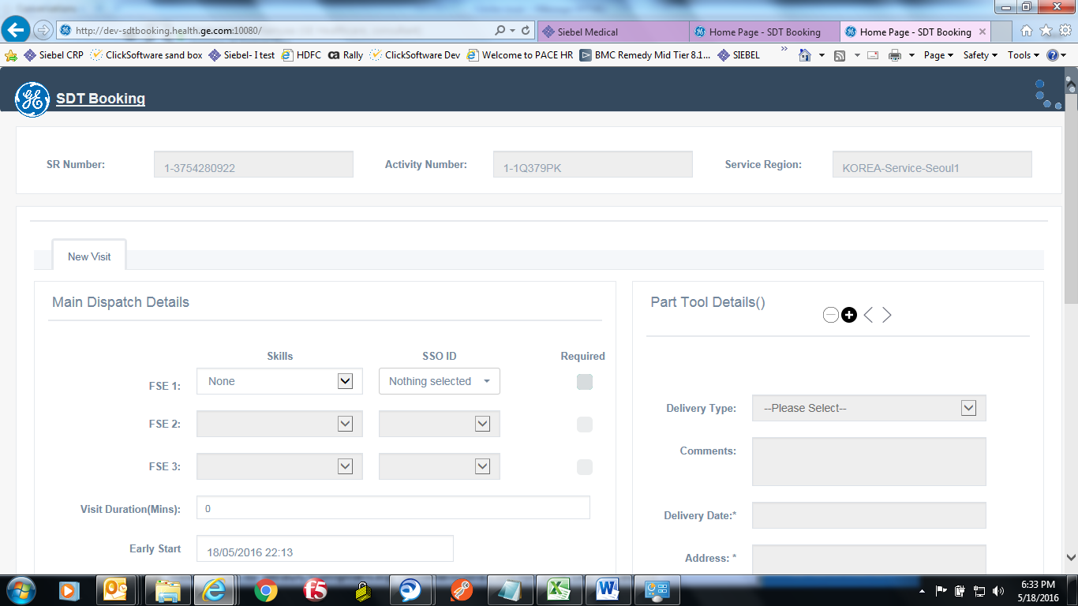

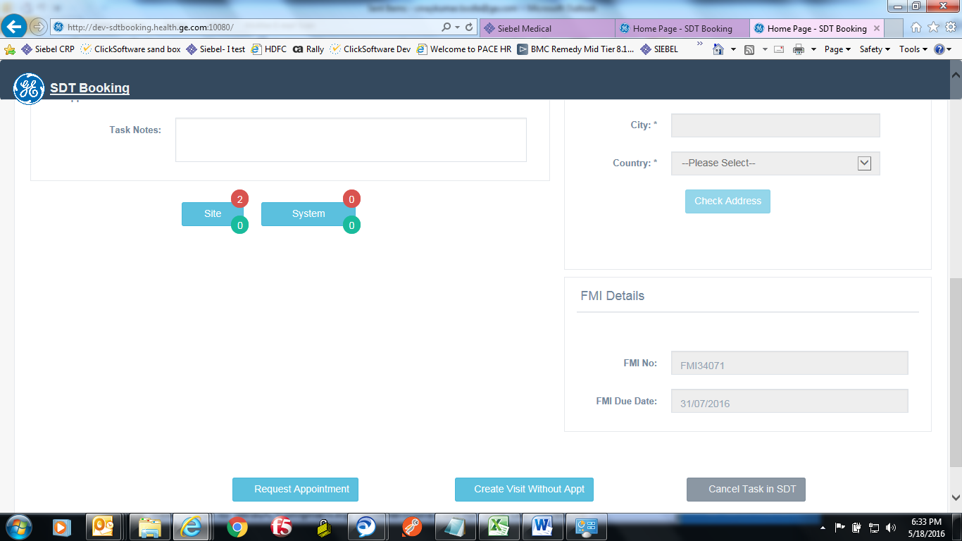

Figure 4.1: SDT Booking Main Page

## Integration and Interface Protocols

| Integration System | Communication Protocol | Description |
| --- | --- | --- |
| SDT Booking and Siebel | Siebel Query API / Deserialize Json Objectl/ OAuth Authentication | SDT Booking is launched from Siebel, where it captures few parameters on the basis of SR / Activity Number and further it calls OAuth Layer to get the token which is valid for 2 hours and call Siebel Query API to retrieve Activity / SR details from Siebel. |
| SDT Booking and ClickSoftware | Calling WCF Web methods / XML Serializer / De-serializer | Calling ClickSoftware WCF exposed web services for different web operations |

## Reports

SDT Booking Tool is a transaction system. It does not offer any Reporting capabilities.

## Application/System Availability and Disaster Recovery

As SDT Booking is a web based application, recovery is limited to re-deploy the code to server.

# Database

SDT Booking Application has no database of its own.

# Design Review

Design Review is captured under DOC1856575

# Design for Testability

Testing will be performed as per all URS, SRS and Design Ids with appropriate rigor and comprehensibility.

## Test Data

## Code Review

Code Review is captured under DOC1856579

## Unit Test

Approval signatures to be added upon completion of Unit Testing in Staging Environment.

# Security

## Authentication

### Internal User Access

SDT Booking internally uses Siebel authentication. There is no additional need of access verification need for SDT Booking Application.

### External User Access

Not Applicable. This application is for GE Employees/contractors only. No external user can access this application.

## Authorization

### Application Level

Table 8-2: Application Level

| SRS ID | Design ID | Title | Description |
| --- | --- | --- | --- |
| SRS-SEC-02 | SDS-SEC-02 | SDT Booking | SDT Booking users shall have a Siebel userid authorized to access SIEBEL in the country associated to the RFS to be assigned. |

### Desktop Level

Not applicable. SDT Booking is a web based application.

### Field Level

Not applicable. The SDT Booking application requires only SSO authentication for users. There is no additional authorization requisite.

### Reporting

Not applicable. SDT Booking is a transaction based application. There is no Reporting applicable.

## Data

### Classification

SDT data is classified as GE Internal

## Patching & Upgrades

### Patching

There is no Patching applicable as part of current release. Patches would be applied in subsequent releases on need basis.

### Upgrades

This is the initial release of SDT Booking Application, there are no upgrades involved. . Upgrades  
would be applied in subsequent releases on need basis.

## Security Specifications

| SRS ID | Design ID | Title | Description |
| --- | --- | --- | --- |
| SRS-SEC-01 | SDS-SEC-01 | SDT Booking | Since Siebel will be operational for 24 x 7 hence SDT booking will be available |
| SRS-SEC-02 | SDS-SEC-02 | SDT Booking | SDT booking cannot be launched as standalone as it depends on few parameters received from Siebel. If the params are null then it means user is trying to launch the application from Standalone and application will block further access. Only Siebel user who has grants to launch “SDT Book Appointment” button |
| SRS-SEC-03 | SDS-SEC-03 | SDT Booking | User cannot launch the activities which are closed in Siebel and they will be shown with a warning message that the activity for which they want to book appointment is closed in Siebel, pls. refer to requirement for the list of activities status for which booking is allowed. |
| SRS-SEC-04 | SDS-SEC-04 | SDT Booking | If SDT booking is not launched due to any network issue then there will be an error message as per the response system. |

# Legal, Compliance, Regulation

SDT Booking is GxP Relevant.

## 21 CFR Part 11 – ERES

No electronic records are stored in SDT Booking. SDT Booking do not manage electronic signature.

## Sarbanes-Oxley

SDT Booking is not subject to Sarbanes-Oxley.

## HIPAA, Data Privacy

SDT Booking is not subject to HIPAA.

# Error Handling & Recovery

Table 10‑1: Error Handling & Recovery

Errors detected by SDT Booking are specified as a part of validations mentioned in SRS document and SDT booking is displaying the error messages from the response system. There is no specific error message from SDT Booking application on its own.

| SRS ID | Design ID | Title | Description |
| --- | --- | --- | --- |
| SRS-SEC-04 | SDS-SEC-04 | SDT Booking Error Handling | Errors detected by SDT Booking are specified as a part of validations mentioned in SRS document and SDT booking is displaying the error messages from the response system. There is no specific error message from SDT Booking application on its own. |

# System Architecture

## Proposed System Architecture

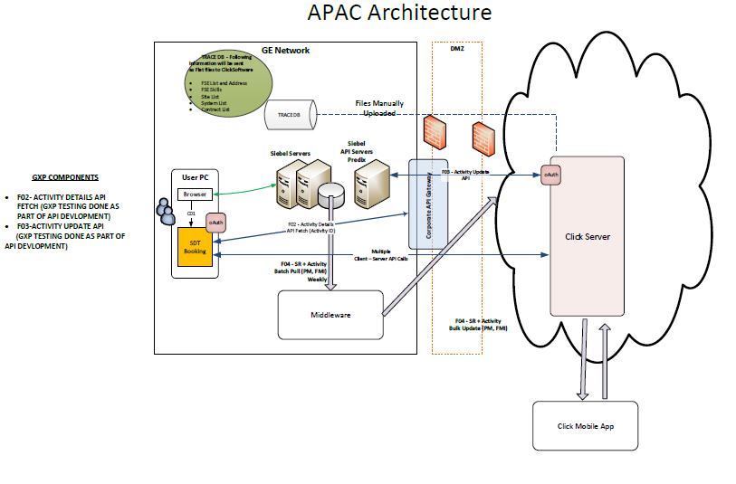

Figure 4‑8: SDT Booking System Architecture

# Deployment Plan

Click

Schedule

Out of GE Network

CRM

(Siebel)

DMZ

GE Network

**Siebel API**

SSO & Oauth 2.0

SDT Booking Web

Invokes SDT Booking

Click

Mobile

## Hosting Architecture

Refer to Technical Architecture Design Document (TAD) for details on the hosting architecture. Document ID : DOC1757330

## 

## Deployment Process

Deployment of the system implementation application configuration and code to the production environment shall be done using a standard procedure and checklist used by the WebCoE team. This procedure includes steps for backup of the environment, migration of code, migration of configuration and any additional build activities that need to occur directly in production.

## Interface Deployment Process

No applicable information

## Maintenance & Support

SDT Booking is supported by the GEHC Services department. Decision to transition support to the IT&PE GAMS team is under the responsibility of the SDT system owner.

## Retirement Strategy

At this point, there are no retirement plans of SDT Booking and associated systems/tools

# Risks/Issues

No risks/issue identified.

# Traceability Matrix

Refer to the Traceability Matrix for SDT Booking.

# References

## Document References

The table below lists reference documents and their MWS Identification numbers:

Table 15‑1: Reference Documents

| Ref ID | Document Description | DOC ID |
| --- | --- | --- |
| 1 | SDT Booking Validation and Test Plan | DOC1757332 |
| 2 | SDT Booking User and System Requirements Specifications | DOC1777605 |
| 3 | SDT Booking Technical Architecture Description | DOC1757330 |

## Definitions

The definitions in the table below apply to specialize terms used in this document.

Table 15‑2: Definitions/Acronyms

| Term | Definition |
| --- | --- |
| SDT Mobile | Or ClickMobile is an iPhone App used by FSEs to manage their visits |
| SDT Schedule | Or ClickSchedule is an enterprise application that provides way of scheduling service personnel and other field resources. |

# Appendix

## Appendix A- List of Countries

Table 4‑1: List of Countries and associated distribution list

| Country Code | Administration and Support distribution list |
| --- | --- |
| APAC | [APACSDT@ge.com](mailto:APACSDT@ge.com) |